Lesson 1 Demo 6: Service Creation

This section will guide you to:

* Create a service in kubernetes

This lab has two sub-section, namely:

1. Creating a service using a yaml file
2. Creating a service using kubectl commands

**Note:** If you don’t have an existing Kubernetes cluster, refer to the Demo 1.1 of Lesson 1.

**Step 1:** Creating a service using a yaml file

* Create a service configuration yaml file

*vi service-example.yaml*

* Add the following code in the *service-example.yaml* file and save it:

*apiVersion: v1*

*kind: Service*

*metadata:*

*name: example-service*

*labels:*

*app: example-service*

*spec:*

*ports:*

*- port: 80*

*targetPort: 4000*

*type: NodePort*

*selector:*

*app: example-pod*

*---*

*apiVersion: v1*

*kind: ReplicationController*

*metadata:*

*name: example-replica*

*labels:*

*app: example-replica*

*spec:*

*replicas: 1*

*template:*

*metadata:*

*labels:*

*app: example-pod*

*spec:*

*containers:*

*- name: example-container*

*image: zlabjp/docker-example:release-0.1.0*

*ports:*

*- containerPort: 4000*

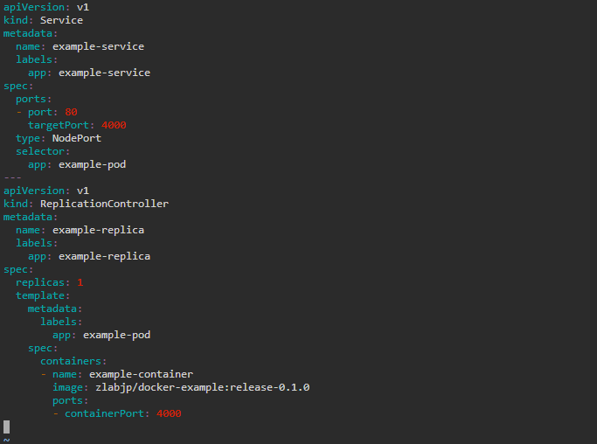

**Note:** Press **Esc** button and enter **:wq** to save and exit the text editor

* Create the service by running the *service-example.yaml* file

*kubectl apply -f service-example.yaml*

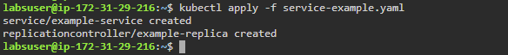

* List all the running services to check the newly created service

*kubectl get service*

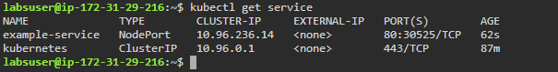

**Step 2:** Creating a service using kubectl commands.

* Use the following command to create a service for the newly created replicas

*kubectl expose replicationcontroller/example-replica*



* Check the newly created services

*kubectl get services*

